Problem2

Accuracy = 0.94
Precision = 0.95
Recall = 0.4982
F Measure = 0.6527
Mu 1= array([[2.11729676], [2.00178424], [2.09192348], [2.0401792 ], [2.01858462], [2.07848594], [2.00259273], [2.052124 ], [2.07384159], [1.97268597], [2.02769579], [2.02677404], [2.01220721], [2.09373266], [2.07537323], [2.04733347], [2.09773404], [2.05521578], [2.05555106], [2.04908871]])
Mu 2 = array([[1.35706765], [1.31237939], [1.31775342], [1.3108699 ], [1.34970912], [1.26975399], [1.30127652], [1.30632173], [1.31702198], [1.27345847], [1.37233019], [1.2814685 ], [1.26069126], [1.38204133], [1.32485818], [1.31165057], [1.32814545], [1.32186326], [1.32409548], [1.24102691]])
W0 = array([[-0.01962532]])
W1 = array([[-1.04949729e-02], [ 6.28270283e-03], [ 3.91740334e-03], [ 1.92018076e-03], [ 6.99429792e-03], [ 3.08831041e-03], [-1.18817029e-02], [ 1.77141808e-02], [ 2.08742098e-02], [-6.81129633e-03], [ 9.49774611e-03], [ 8.67893447e-03], [-1.12055439e-02], [-9.18089832e-03], [ 4.21504660e-03], [-9.61663472e-03], [-2.08508439e-02], [ 4.99492845e-03], [ 1.93842747e-05], [ 3.78743113e-03]])

Problem 3
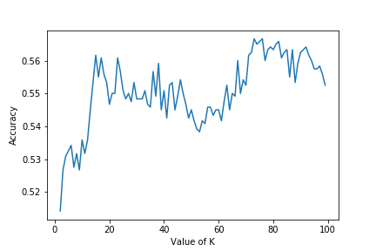
We can see the accuracy fluctuates with K and for K = 73 we get max accuracy

for K = 73 provides max accuracy
for K = 76 provides max precision
for K = 5 provides max recall
for K = 5 provides max Fmeasure

Problem 5.1

Accuracy = 0.4966
Precision = 0.4967
Recall = 0.5203
F Measure = 0.5081
Mu 1= array([[1.10933176], [1.04337353], [1.08710064], [1.03513281], [1.0540895 ], [1.01931427], [1.02233875], [1.05943621], [1.04492486], [1.0095645 ], [1.07407652], [1.03634172], [1.07338496], [1.07065069], [1.06676536], [1.03717917], [1.12545816], [1.0195795 ], [1.00959656], [1.07928161]])
Mu 2 = array([[1.20637971], [1.24578597], [1.23909664], [1.29948946], [1.21352091], [1.23816039], [1.24382555], [1.19727223], [1.21312223], [1.28847044], [1.29330546], [1.28408775], [1.26635248], [1.21113559], [1.21150247], [1.23737768], [1.26350945], [1.20329051], [1.26980984], [1.21744158]])
W0 = array([[5.78328839e-05]])
W1 = array([[ 5.25100739e-05], [-9.26007998e-06], [ 3.18304450e-05], [-3.43503148e-05], [-3.84234125e-05], [-9.70487776e-06], [ 3.95067380e-05], [ 2.11408796e-05], [-8.45523628e-06], [-5.45845613e-05], [-5.01263099e-05], [-4.66807428e-05], [-2.18103052e-05], [-5.94580898e-06], [ 5.19091173e-05], [-3.28798430e-06], [ 2.55625127e-05], [-9.67633571e-06], [ 1.73328027e-05], [ 3.54779597e-06]])

Problem 5.2
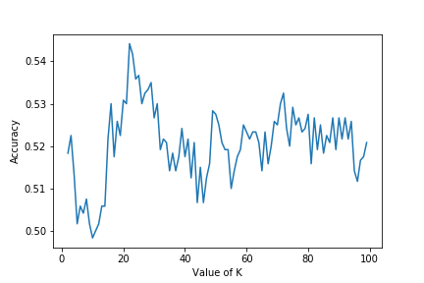
We can see the accuracy fluctuates with K and for K = 22 we get max accuracy

for K = 22 provides max accuracy
for K = 22 provides max precision
for K = 99 provides max recall
for K = 99 provides max Fmeasure

Problem 6
For DS1 data sets, LDA performs really well where single multivariate gaussian distribution is used but for LDA doesn’t seem to perform that well when we have used dataset mixture of 3 gaussian is DS2.
KNN classifier doesn’t seem to perform at all in any of the datasets

